**Science Night: Activity Write-Up**

**Name of Activity:** Navigating the Night Sky

**Number of volunteers needed:** 7-8 students

**Time needed to complete the activity:** 15 minutes (5 for creating the planisphere, 10 in the inflatable planetarium)

**Materials:**

* Inflatable planetarium
* Printable planisphere <http://mybb.gvsu.edu/bbcswebdav/pid-1447523-dt-content-rid-14451230_1/courses/GVPHY205.10.201310/starwheel.pdf>
* Scissors
* Staplers or gluestick

**Procedure:**

* Students will begin at a table outside the inflatable planetarium. At this station they will create a planisphere using the template listed above. GV student volunteers will introduce children to the planisphere using the introduction information below. This will not be read to the students, but summarized and explained as they work.
* After creating their own planisphere, one student (working the front of the planetarium) will allow them inside the planetarium. A GVSU volunteer will then partner up with the students in groups of 2-4 and explain how to use the planisphere to locate constellations in the sky. They will explain how to use the planisphere using the directions listed below.
* Students will locate the summer and winter constellations using their planisphere. The constellations present in each season are listed below.
* Students may take their planisphere home. As students leave the planetarium they will be given an astronomy handout. This will encourage them to continue learning about the constellations at home.

***Introduction to the planisphere:***

A planisphere is a sky chart that can be set to show the location of objects in the sky at a given time and date. It is relatively small and portable, making it a very convenient tool for navigating the night sky. Planispheres are designed to be accurate for a specific observer latitude, but are useful over a range of latitudes.

The white sky area can be rotated around the center of the planisphere, corresponding to the apparent rotation of the night sky around the North Celestial pole. The North Star (Polaris) is located in the sky near the North Celestial Pole and is located near the ‘center’ of the planisphere. The solid curved portion of the planisphere which covers a portion of the bottom of the sky represents the horizon, where the earth meets the sky. To use the planisphere it must be oriented so that the planisphere horizon corresponding to the direction you are facing is at the bottom.

The ‘sky’ portion of the planisphere can be rotated either clockwise or counterclockwise. As the night sky rotates around the north pole due to the rotation of the earth, objects in the sky rise above and set below the horizon throughout the night. These objects are circumpolar, meaning they have declinations greater than 90* minus the observers latitude, and therefore will never go below the horizon.

The direction of the night sky rotation can be determined by remembering that objects rise in the east and set in the west. Therefore the planisphere should be rotated counterclockwise.

***How to Use the Planisphere:***

To use the planisphere it must be set to a specific date and time. The months and days throughout the year are marked along the outer edge of the rotating part of the planisphere. Standard times are indicated on the outside edge of the fixed portion of the planisphere below the horizon. An hour will need to be added for daylight savings time when necessary.

To set the planisphere to display the sky for a specific date and time, rotate the sky to the appropriate date and time are aligned. With the planisphere set to a specific date and time of interest, orient it with the azimuth direction (N,E,W) at the bottom of the sky. The sky on the planisphere will correspond to the night sky you are facing.

To determine when a constellation will rise on a specific date, rotate the planisphere sky until the object is aligned with the eastern horizon. Read the time of day corresponding to the specific date.

To determine when an object will set on a specific date, rotate the planisphere sky until the object is aligned with the western horizon, and read the corresponding time for the specified date.

***Circumpolar Constellations:***

* Cassiopeia
* Cepheus
* Draco
* Ursa Major
* Ursa Minor

***Winter Constillations:***

* Canis Major
* Cetus
* Eridanus
* Gemini
* Orion
* Perseus
* Taurus

***Summer Constillations:***

* Aquila
* Cygnus
* Hercules
* Lyra
* Ophiuchus
* Sagittarius
* Scorpius

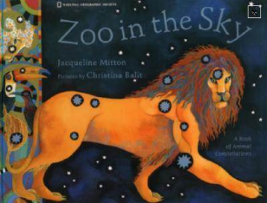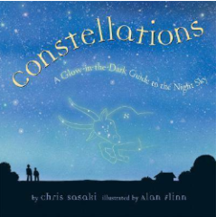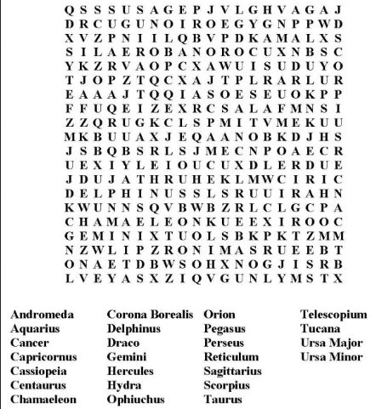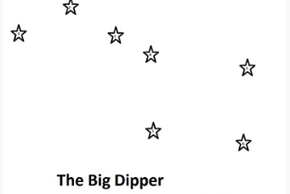C:\Program Files (x86)\Microsoft Office\MEDIA\CAGCAT10\j0301076.wmfNavigating the Night Sky Activity Sheet

**Online Resources**

Goodsitesforkids.org/astronomy

Kidsastronomy.com

Kidsknowit.com/interactive-educational movies/astronomy

Kidssites.com/sites-edu/space.htm

**Read about Astronomy!**

Look for these books to learn more about the night sky. Check your school library or local public library for more great books!

*Constellations: A Glow-In-The-Dark Guide to the Night Sky*

*By: Chris Sasaki*

*Zoo In the Sky: A Book of Animal Constellations*

*By: Jacqueline Mitton*

Constellation Word Search

**Can you find the hidden constellations within the grid of letters?**

**All About The Big Dipper:**

The big dipper is the common name for the constellation Ursa Major. This constellation received this name because the major stars can be seen forming a large ladle or dipper. Many people believe this figuration was used in the 19th century when runaway slaves would ‘follow the drinking gourd’ to the north and freedom.

Can you connect the stars below to make the big dipper constellation?

**Look for Constellations in your own backyard…**

With a parent or guardian and your planisphere, go outside on a clear night and look for objects in the sky. Can you teach your family members how to locate your favorite winter constellation?