Nichole Matzke
SST 309-01: Geo-Diary
11/03/11

Hillsdale, MI-Home Base

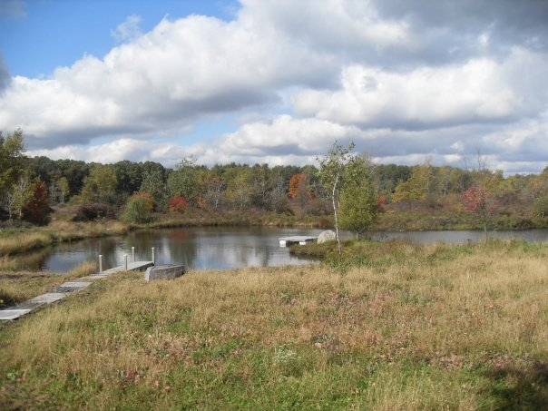

3:00 PM Saturday, September 10 Southwest
1. This is the pond and woods area that is overlooked from the north side of the home that I grew up in. (Relative Location; Natural Characteristics of Place)

Places we like to visit

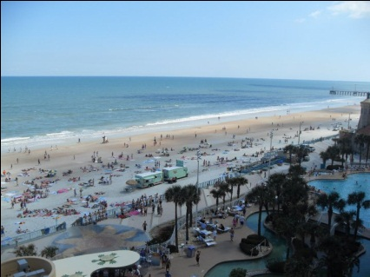

10:00 AM Monday, March 8, 2010 Southwest
2. One of my family’s typical vacation spots is at Daytona Beach. We like to soak up the sun, play in the sand, and look for sea-shells along the ocean. (Human-Environment Interaction; Natural and Human Characteristics of Place)
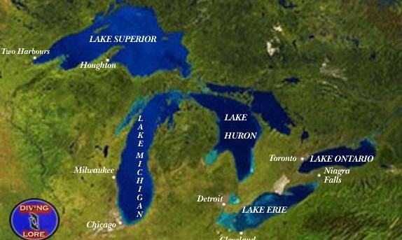

5:20 PM Wednesday, November 2 (Internet)
3. We also enjoy visiting the five different Great Lakes of Michigan for a relaxing get away where we find many fun outdoor activities (fishing, boating, hiking, etc.) to keep us occupied. (Natural Region)

A part of growing up…

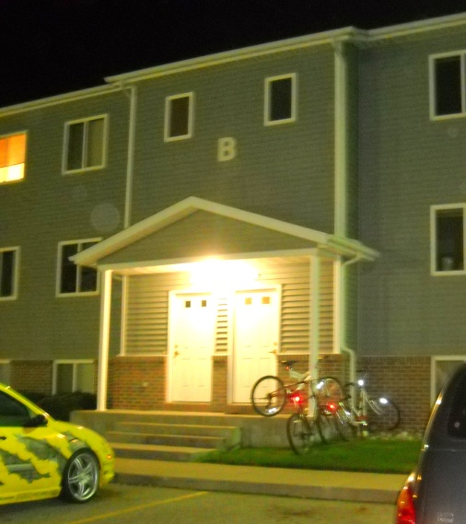

7:30 PM Wednesday, November 2 Northwest
4. A part of growing up was moving out of the house that I grew up in and getting my own apartment. I currently live in Hillcrest apartments at 10485 48th Ave. in Allendale MI. (Absolute Location)
Go Lakers!

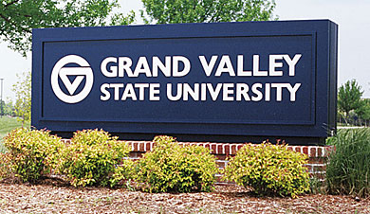

8:00 PM Wednesday, November 2 (Internet)
5. I am a student at GVSU studying to be an Integrated Science, Elementary Education Teacher. GVSU is located at 1 North Campus Drive in Allendale MI. (Absolute Location)

Transportation

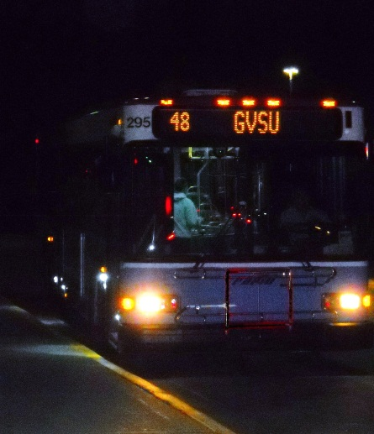

9:10 PM Tuesday, November 1 South
6. My main form of transportation to get to and from campus each day is by using the GVSU bus transportation system. (Movement of People)

Study, Study, Study!

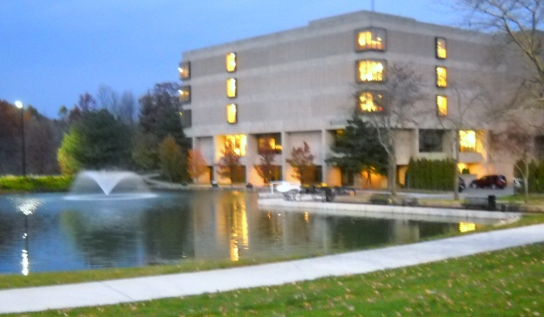

7:00 PM Wednesday, November 2 Northeast
7. I spend most of my time studying for my classes by using the resources and technology available at the Zumberge Library on campus which is located directly across the pond from the Kirkhof Center. (Relative Location; Movement of Ideas)

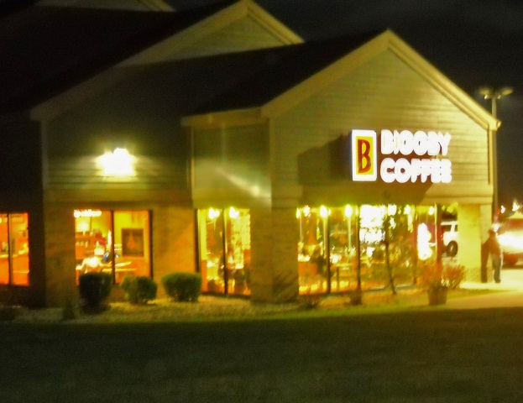

7:15 PM Wednesday, November 2 Southwest
8. To switch up the environment from the library, I usually go to Biggby to study for classes and grab a cup of coffee. Biggby is in a convenient location because it is just down the road from my apartment right next to Burger King. (Relative Location; Movement of Goods and Services)
What to do?

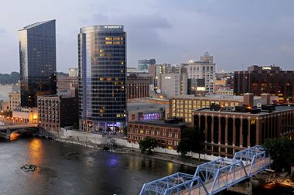

6:30 PM Wednesday, November 2 (Internet)
9. When I need a break from studying, downtown Grand Rapids is a big city that I love to go to because of its exciting nightlife, dining, shopping, and events. (Human Characteristic of Place)

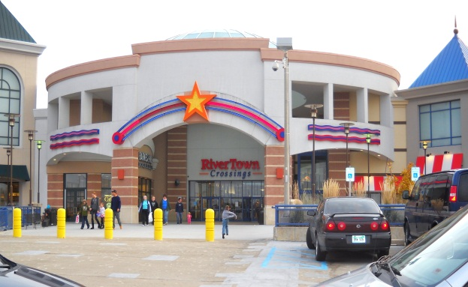

5:20 PM Sunday, October 30 Southeast
10. I always enjoy a good day at the mall. I ‘shop til’ I drop’ at RiverTown Crossings which is at 3700 RiverTown Parkway in Grandville, Michigan. (Absolute Location, Movement of Goods and Services)
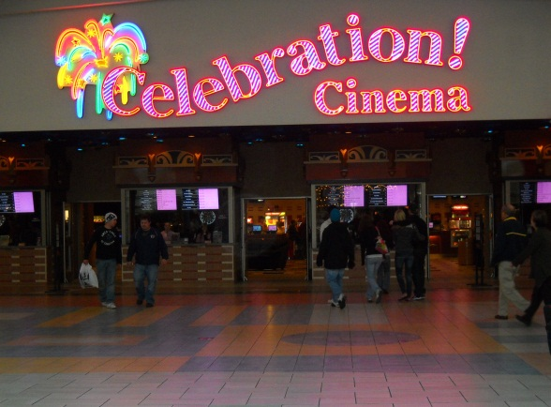

5:27 PM Sunday, October 30 South
11. Going to watch a movie is always something fun that my family, friends, and I love doing. We usually go to the Celebration Cinema which is on the upper level of RiverTown Crossings mall near the food courts. (Relative Location; Movement of Service)

Shopping for food

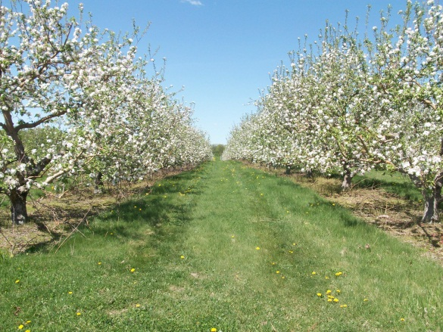

5:38 PM Wednesday, November 2 (Internet)
12. I shop for groceries at Motman’s. Motman’s Fall Farm Market always has fresh, clean produce that they grow themselves. (Movement of Goods; Human-Environment Interaction)

